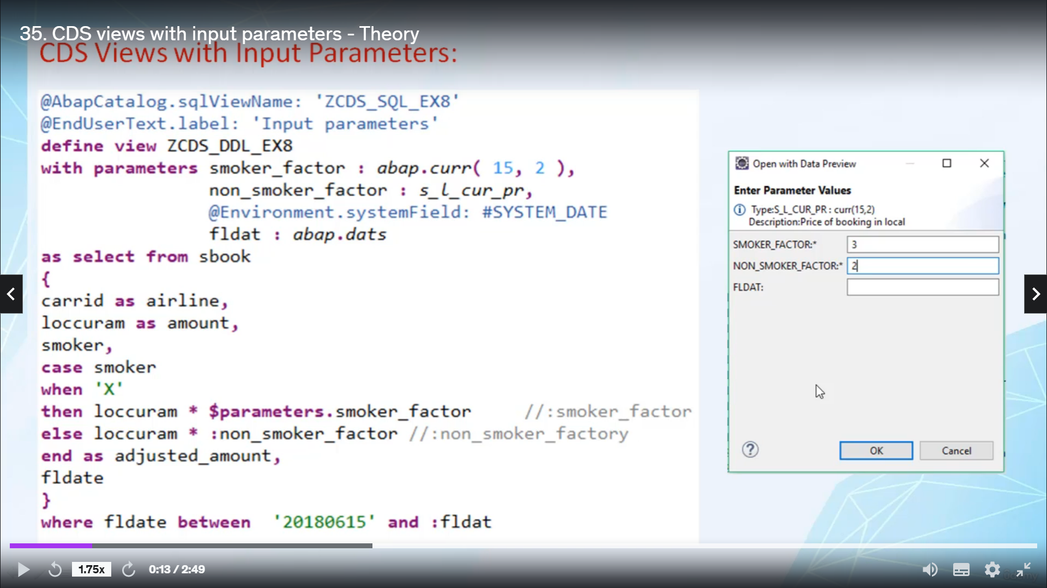

Welcome back.

In this video, I will tell you how to use and put parameters in absolutist view.

So let's start.

You define input parameters by placing additions with barometer of cities, view name, and the parameters

are then defined in commerce at least.

Each parameter, each input parameters must be tied with elementary data type.

This can be a predefined evolutionary date or it can be of any detail type.

You can use annotations to provide additional information for barometer's.

There are two ways to address input parameters, the longer version is with prefix parameters and the

shortened version is with simple colon.

You have to use this to prefix before that immediately.

It is recommended to use the long version because only the long wooden is supported by source code completion,

featuring above development tool.

You can use input parameters in various positions in absolutist view, eliminate and select list approved

of an arithmetic expression, right.

Sort of condition in a very close or having close operand directly after case in case expression.

And sort set of condition in an on condition enjoyment.

If you open the door for this view with input parameters, you are prompted to intellectual values for

all the input parameters.

It is currently not possible to define optional input parameters for this view.

That is, when you access a series with parameters, you have to provide actual values for all the parameters.

And hence, your portion is over.

Now let's create one absolutist view where we will use input barometer's.